**Appearance :**

_____________________________________________________  
_____________________________________________________  
_____________________________________________________

The cat meets … ________________________________________  
_______________________________________________________________________________________________________________________________________________________________

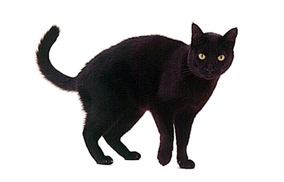

**LO: To write a character description.**

**Personality**  
  
I think that the cat is _________________________________  
because ____________________________________________  
_________________________________________________________________________________________________________________________________________________________  
______________________________________________________________________